### Corie Beale

## Proposal Topic

myCourses Calendar View

## Primary User Group

Students who use myCourses

## Specific User Goal

Students want to see what they have left to do in calendar format. They may be looking ahead of time to see what assignments are coming up, such as the upcoming week to plan accordingly.

## Primary Problem in Achieving Goal

Create a more legible calendar list to remove clutter and small item sizes.

## Current Task Flow

1. myCourses home page

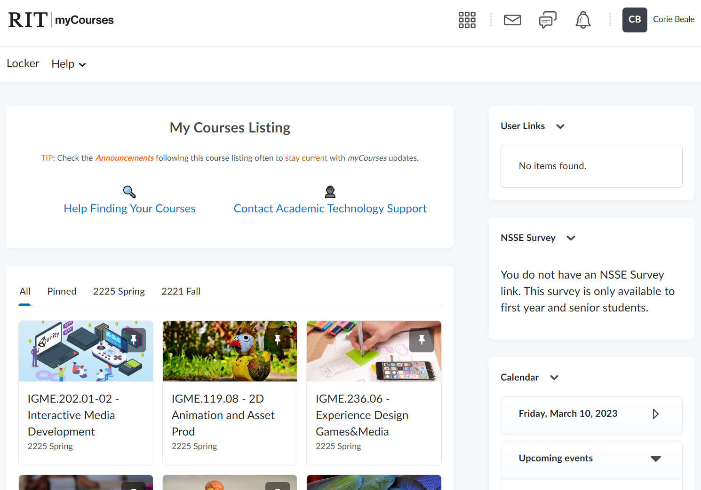

1. Calendar widget

Problem: Calendar is cluttered with information over all days, although some are not assignments. There is no setting to change this.

1. Calendar page

Problem: Many assignments typically due at the end of the day on either Friday or Sunday. Therefore, information is cluttered at the bottom and not easily identifiable. The student must click on each one to see each assignment or find the assignment they are looking for. The color coding is also unclear. There is no key to understand what color is which class, which may help to decipher the clutter.

1. Clicking an assignment on the calendar view (and clicking “More…”)

“More…” redirects to:

Problem: Many key presses are required. Instead of going straight to the assignment’s page, a replica of the assignment is made as a “summary.” This is not intuitive since the assignment’s page would tell the user the same exact thing. If the student wanted to submit the assignment, they would need to click on the blue title of the assignment.

* Extra: Potentially irrelevant information

While this may be beneficial to remote students, Zoom meetings are consistently shown for classes that offer it. They add clutter, such as adding to the blue dots shown on step 3. It becomes almost impossible to navigate unless assignment dates are known before navigating this calendar.

## Proposed Changes

[Tell me, specifically, how you will improve the user experience. What will you redesign and why? Provide this in numbered list form.]

1. Customizable calendar
   1. Add types of events so that the student can specify what content they want to display on the calendar. All types will be applied by default but will save changes per student.
2. Expandable calendar
   1. Added ability to resize the calendar widget, similar to a text box on a submission form. This will improve readability.
3. Key code for courses and colors
   1. Allow the user to easily identify what colors are what courses. Add feature to change colors if needed to assist with colorblindness. This key will always be displayed for easy reference.
4. Better navigation
   1. Instead of providing a summary, clicking on the assignment or event will bring the student straight to the relevant page so that they can perform actions instead of only reading text.
5. Content display rework
   1. Currently, the format is header: course name, body: event name. This will be reversed to show the most relevant content first and improve navigation speed so the user finds what they want fast.